**Practical 9**

Flow Oriented Modelling: Data Flow Diagram

Project Name: Automated Attendance System

Group Members: Meet Variya (18CP022)

Chintan Darji (18CP023)

Deep Patel (18CP204)

**Level 0:**

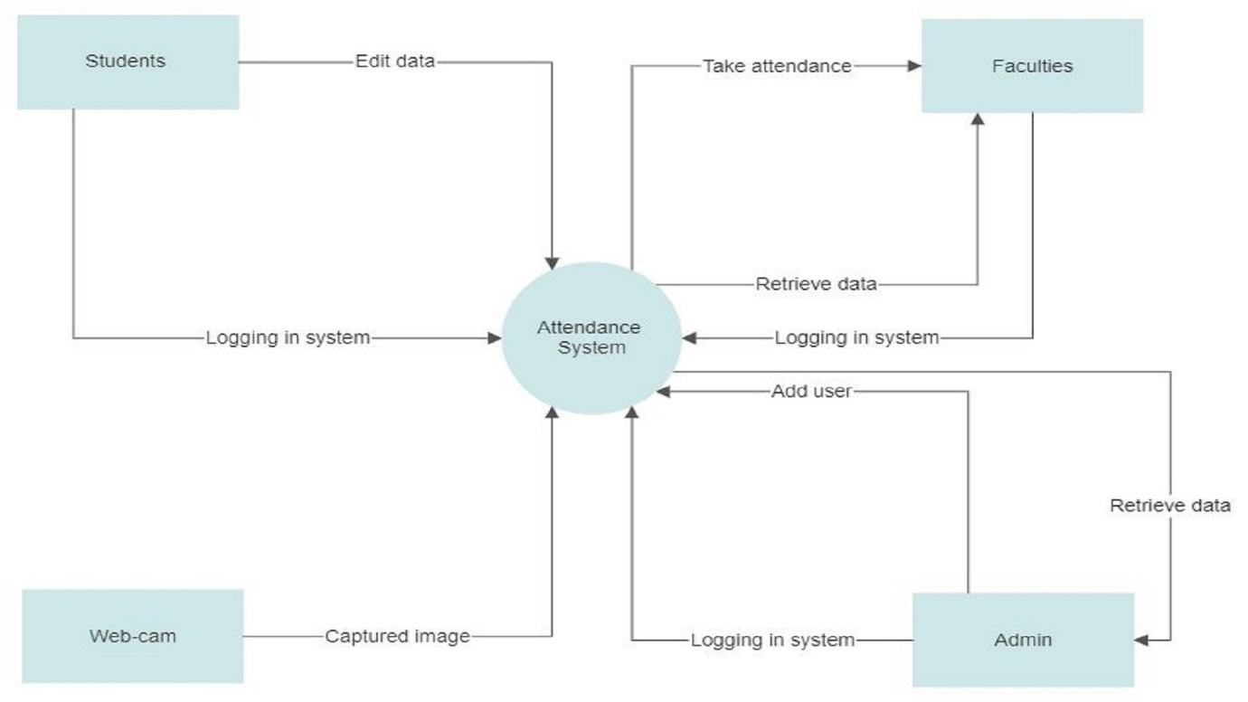

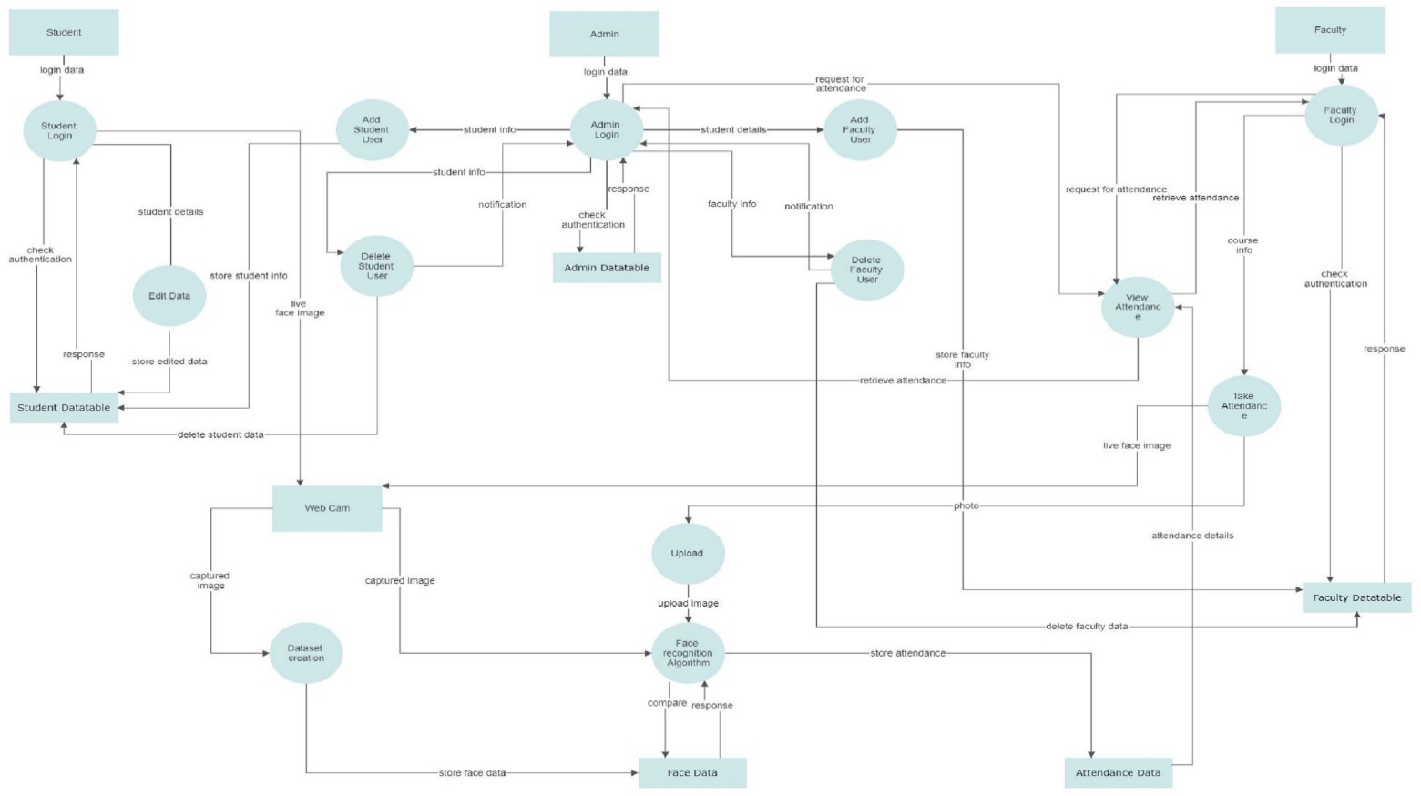**Level 1:**

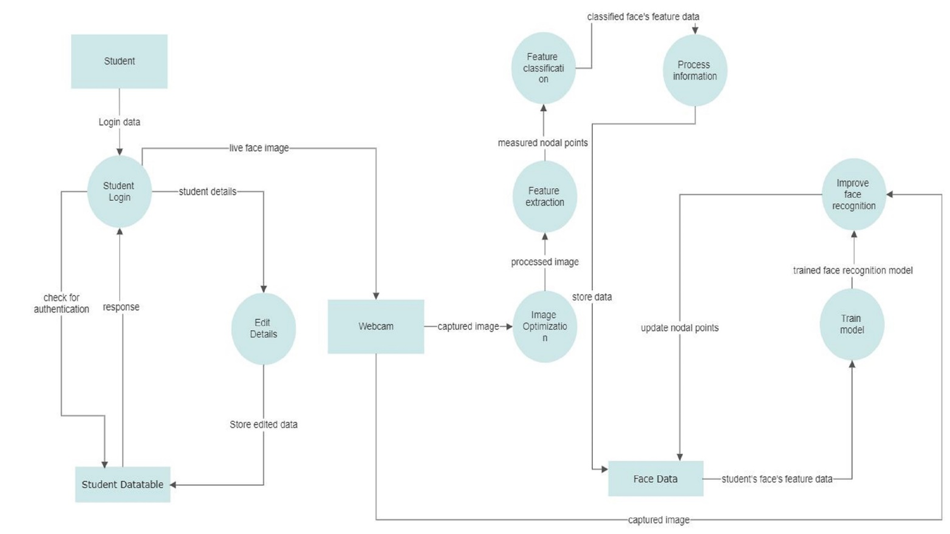**Level 2:(Student)**

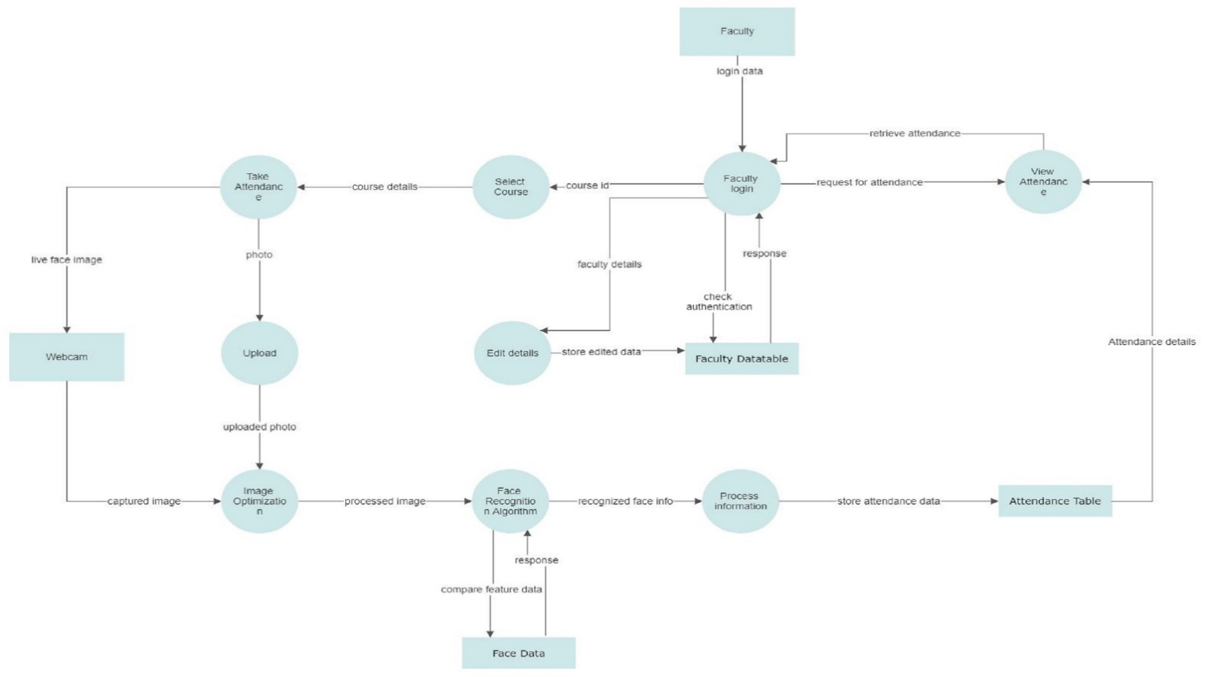**Level 2:(Faculty)**

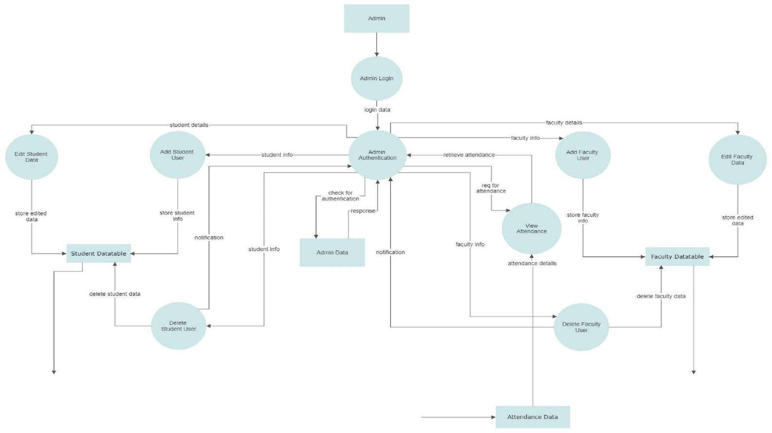**Level 2:(Admin)**